DCM Name | DCMBathingIntervention
DCMType: | Nursing process: intervention
DCMiD:
DCM Oid:
DCM Repository Id:
File name | 0000.doc
Version doc.: | 0.3
Code/Keyword: | Activity in bathing, interventions in bathing, actions in bathing.
Language: | English
Publication Status: | Status: | Date:
Publication Status: | Author Draft(en);  Committee Draft(en);  Organisation Draft(en);  Submitted(en);  Withdrawn  Rejected(en)  Obsolete  Approved for testing  Approved for Production Use  Superseded | 4 January 2010
Authors: | Drs. A.T.M. Goossen, Dr. W.T.F. Goossen, Drs. Y.J. Koster-de Jong. Results 4 Care.
Contact information : | Info@Results4Care.nl
Requirement specification and Review of content
Endorsing Authority
Verification and Validity
Quality label/ Certification

Copyrights: | Licenses of source material  Not applicable  Use of the DCM  The DCM is open source, so free to use, not to be changed.  Changes in the content en codes are seen upon as a infringement of copyright and is damaging for the goal of use: realisation of semantic interoperability.  You can suggest changes at results4care@cs.com  Revision suggestions will be looked at and may lead to:  - revised DCM and results if accepted  - variations of the DCM adapted on a local situation.  This is all based upon : a “common ownership” but not a “special stewardship”.
DCM Format
Additional formats | HL7 template  Archetype  Zorginformatiemodel  Plain XML

Version management
version | date | Changes | Reason of change | author
0.3 | 04-01-2010 | Edits | Review | Dr. William Goossen, Results 4 Care
0.2 | 22-12-2009 | Missing parts added in DCM. Mapping table completed. | Completion | Drs. A. Goossen-Baremans
0.11 | 29-05-2009 |  | First draft | Drs. Y.J. Koster- de Jong, Results 4 Care.

Purpose
This concerns the purpose of recording the interventions needed in bathing clients that need support in bathing.

Evidence based
After formulating / determining a nursing diagnosis self care deficit bathing and the corresponding goals / expected outcomes the interventions / actions are determined. In this the interventions are designed to ensure that the expected outcome can be achieved.
In the Nursing Intervention Classification, the NIC (Bulecheck et al, 2008), possible interventions are listed which could be performed in case of limitations or self care deficit concerning bathing (nursing diagnosis) these interventions are in relation to the nursing outcomes described in the Nursing Outcome Classification, NOC (2008). The nursing diagnosis and the outcome are determined in other DCM’s.

Description of the variables
For the description of variables belonging to this DCM a spreadsheet in Excel is used. The filename of the spreadsheet belonging to this DCM is: DCMBathingIntervention_V_03.xls.

Instruction
When conducting nursing interventions in relation to a nursing diagnosis and a nursing outcome it concerns patient related interventions or actions.
The usual aspects of nursing care to clients to support them in their activities of daily living are applied. In this the culture and the age of the client are accounted for and the degree in which the client himself or his neighbours participate in the care. On this agreements are made between nurses and care providers and the client and his neighbours. These agreements are recorded in the patient record.

Interpretation guidelines
After collecting the data and assessment of these data the interventions are planned. The level of detail of the description of the interventions and actions depends on the health care facility. The variables included in this DCM can, but don not necessarily all have to be included in the Electronic Patient Record

Care process / dependence
The nursing intervention is part of the care process. By implementing the interventions, either the implementation, the client is supported in bathing or the bathing will be completely conducted by the nurse / care provider. With the nursing intervention it is tried to achieve the expected outcome / goals. After an evaluation of the results nursing diagnosis and interventions might be adjusted. The following figure shows the nursing process which a patient goes through if he is admitted in a hospital (Boone, 2009).
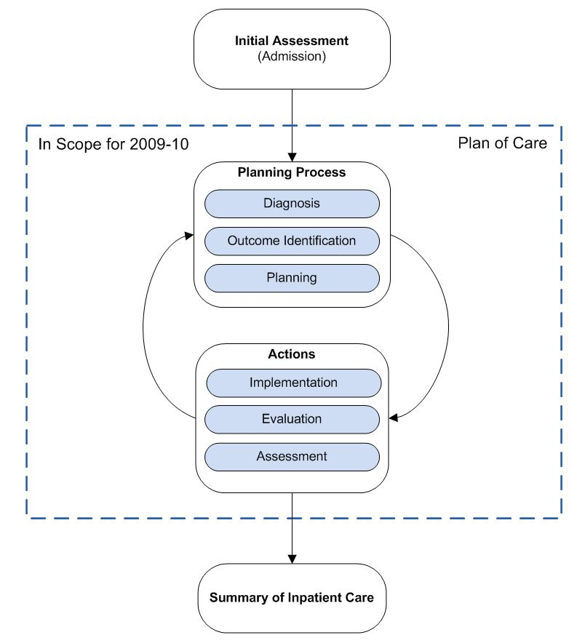
Figuur 1. Verpleegkundig proces (IHE, 2009).

An example of the instrument
Not applicable.

Screenshots
Not applicable.

References

Projects:
None.

Literature:
Albertsnagel, E.,Diagnosen ,resultaten en interventies. Wolters-Noordhoff, Groningen 2002.
Boone, K.W., (2009). Technical Framework Supplement. Patient Plan of Care (PPOC). Intergrating the Health Care Enterprise (IHE).
Bulecheck, G.M., Butcher, H.K., McCloskey Dochterman, J., (2008). Nursing Interventions Classification (NIC). St. Louis, Missouri, Mosby Elsevier.
Kwaliteitsinstituut voor de Gezondheidszorg CBO, (1999). Herziening consensus verpleegkundige verslaglegging. Utrecht, CBO.

Sesink, E.M., Kerstens, J.A.M., (2006). Basisverpleegkunde. Houten, Bohn Stafleu Van Loghum.
Moorhead, S., Johnson, M., Maas, M., (2008). Nursing Outcome Classification. St Louis, Missouri, Mosby.
NANDA International, (2009). Nursing Diagnoses: Definitions & Classification. Philadelphia, NANDA International.
Transferpunt Vaardigheidsonderwijs, (1994). Werkcahier MBO Persoonlijke hygiene. Maastricht, Transferpunt Vaardigheidsonderwijs.
World Health Organization (WHO), (2005-2007). International Classification of Functioning, Disability and Health (ICF). Geneve, WHO. Verkregen op 22 december 2009, van http://class.who-fic.nl/browser.aspx?scheme=ICF-nl.cla
Zorgdossier Livio. Zorg, wonen en Gezondheid. Enschede.
Zorgdossier Carint Reggeland groep. Hengelo.

Vocabulary:
SNOMED CT 2.16.840.1.113883.6.96
LOINC 2.16.840.113883.6.1
ICNP 2.16.840.1.113883.6.97 (Obtained on 22-12-2009, from http://www.oid-info.com/get/2.16.840.1.113883.6.97)
ICF 2.16.840.1.113883.6.254
NOC: 2.16.840.1.113883.6.16
NIC 2.16.840.1.113883.6.15
NANDA 2.16.840.1.113883.6.20
Omaha 2.16.840.1.113883.6.98
It is possible that people in this domain use different coding and value sets that used in this DCM. In that case, we as developers appreciate it if we were to be informed.
For the coding the use of terminologies like SNOMED CT and/or LOINC, or one of the classifications of the WHO family of classifications (for example ICD10, ICF, ICNP) has been preferred. The codes that are used are, by our opinion the best possible match between the data item (variable and/or value)and the concept/ concepts as set out in the terminology or classification. It is possible that a very rigorous analysis of one of these terminologies variations emerge that are just as good or even a better match, for instance if another perspective is chosen. There is a small chance that in the future codes for certain data items are being altered. Where we did not find a code, for now, Results 4 Care codes were made and missing concepts will be asked to SNOMED CT.

Remarks
The choice whether speaking of self care, self-help or limitations is up to the nurses or care providers themselves. Often this has to do with the vision and policy of the care facility. The consistent use of these terms throughout the care process in an individual facility is the responsibility of the facility itself.
In the mapping table it is noted that the variables that belong to bathing fail to connect sufficient enough between the data collection, NANDA signs and symptoms NIC interventions and activities and NOC indicators to make a fluent support process possible. This problem will be addressed in the international working group of the IMIA NI.

Disclaimer
Results 4 Care B.V. gives the utmost care to the reliability and timeliness of data in this DCM, Detailed Clinical Model. Errors and inaccuracies may occur. Results 4 Care is not responsible for damages resulting from errors or inaccuracies in the information, nor for damages arising from problems caused by, or inherent in the spreading of information via the Internet, as failures or interruptions from either errors or delays in the distribution of information or services by Results 4 Care, by means of the website repository or by e-mail, or otherwise electronically.
Results 4 care does not accept responsibility for possible damage suffered as a result of the use of data, advise or ideas provided by way of this DCM. Results 4 Care does not accept responsibility for the content of information in this DCM to which or from which using a hyperlink or otherwise, is referred.
In case of contradictions in the mentioned DCM documents and files the priority of the relevant documents is stated by the most recent and highest version mentioned in the revision (version management).
In case information that is included in the electronic version of this DCM is also provided in writing, in case of textual differences the written version will determine. This applies if the version description and date of both are equal. The definitive version has priority over a concept version. A revised version has priority over a previous version.

UML

